ETL, Data Integration, Data Transformation and Data Load Tutorial
Video of solution:
https://leedsbeckettreplay.cloud.panopto.eu/Panopto/Pages/Viewer.aspx?id=3453cc9d-64b7-4945-89bf-a981008b7d16&instance=my-prod

employee db (run scott script)
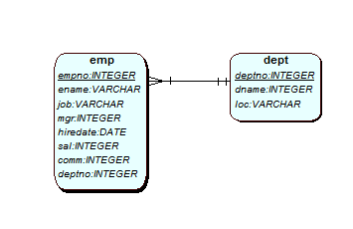

Your role is to create the ss model below and populate it with data from the emp/dept tables.
A DW project has designed the star schema below, to support the reports/investigations.
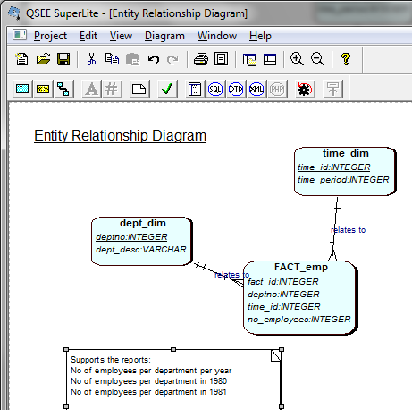

Design and Analysis
Open up Apex and ensure you have tables emp and dept
( CREATE table emp AS SELECT * FROM scott.emp;
CREATE table dept AS SELECT * FROM scott.dept; )

Look at the data in emp and dept, and the data above in the spreadsheet.

Task 1: Understand the data you need
Look at the star schema model and work out the data you will have in each of the tables (dept_dim, time_dim and fact_emp). You could do this in excel or on a piece of a paper.

Task 2: Design of the ETL script

- Populate the dept_dim

SCOTT.DEPT: DEPTNO AND DNAME
EMPS_DATA: DEPARTMENT

Extracts: List the data you need to select, from where?
Data Quality Checks : What checks could you do on the data?

- Populate the time_dim
Extracts: List the data you need to select, from where?
Time_DIM – time_id … doesn’t exist therefore you will have to have a surrogate key, populated by a sequence

Insert into dept_dim SELECT deptno and dname from dept table
Insert into dept_dim department FROM emps_dept where department not in dept_dim already

Quality checks – check dept_desc is unique

Time_period will come from hiredate in emp table.
Scott.EMP: hiredate – I would use only date as year. So, you will need to extract year, using EXTRACT function in SQL. Examples given in SQL tutorial week 1.

INSERT in values – 1981, 1982, 1987 ….

Data Quality Checks : What checks could you do on the data?
- The issue is that emps_data does not contain any date data.

- Populate the fact table
How?
- Research into populating fact tables

Two approaches – pay around with the reports GROUP BY.
- Populate all the ids, from the dimension tables and then update the measures from a temporary table.
- Create a tmp_table with the results you want to see in the fact table. Then insert this into the fact table.

Rework this section until you have a design for the ETL script. You may wish to play around in Apex for it.
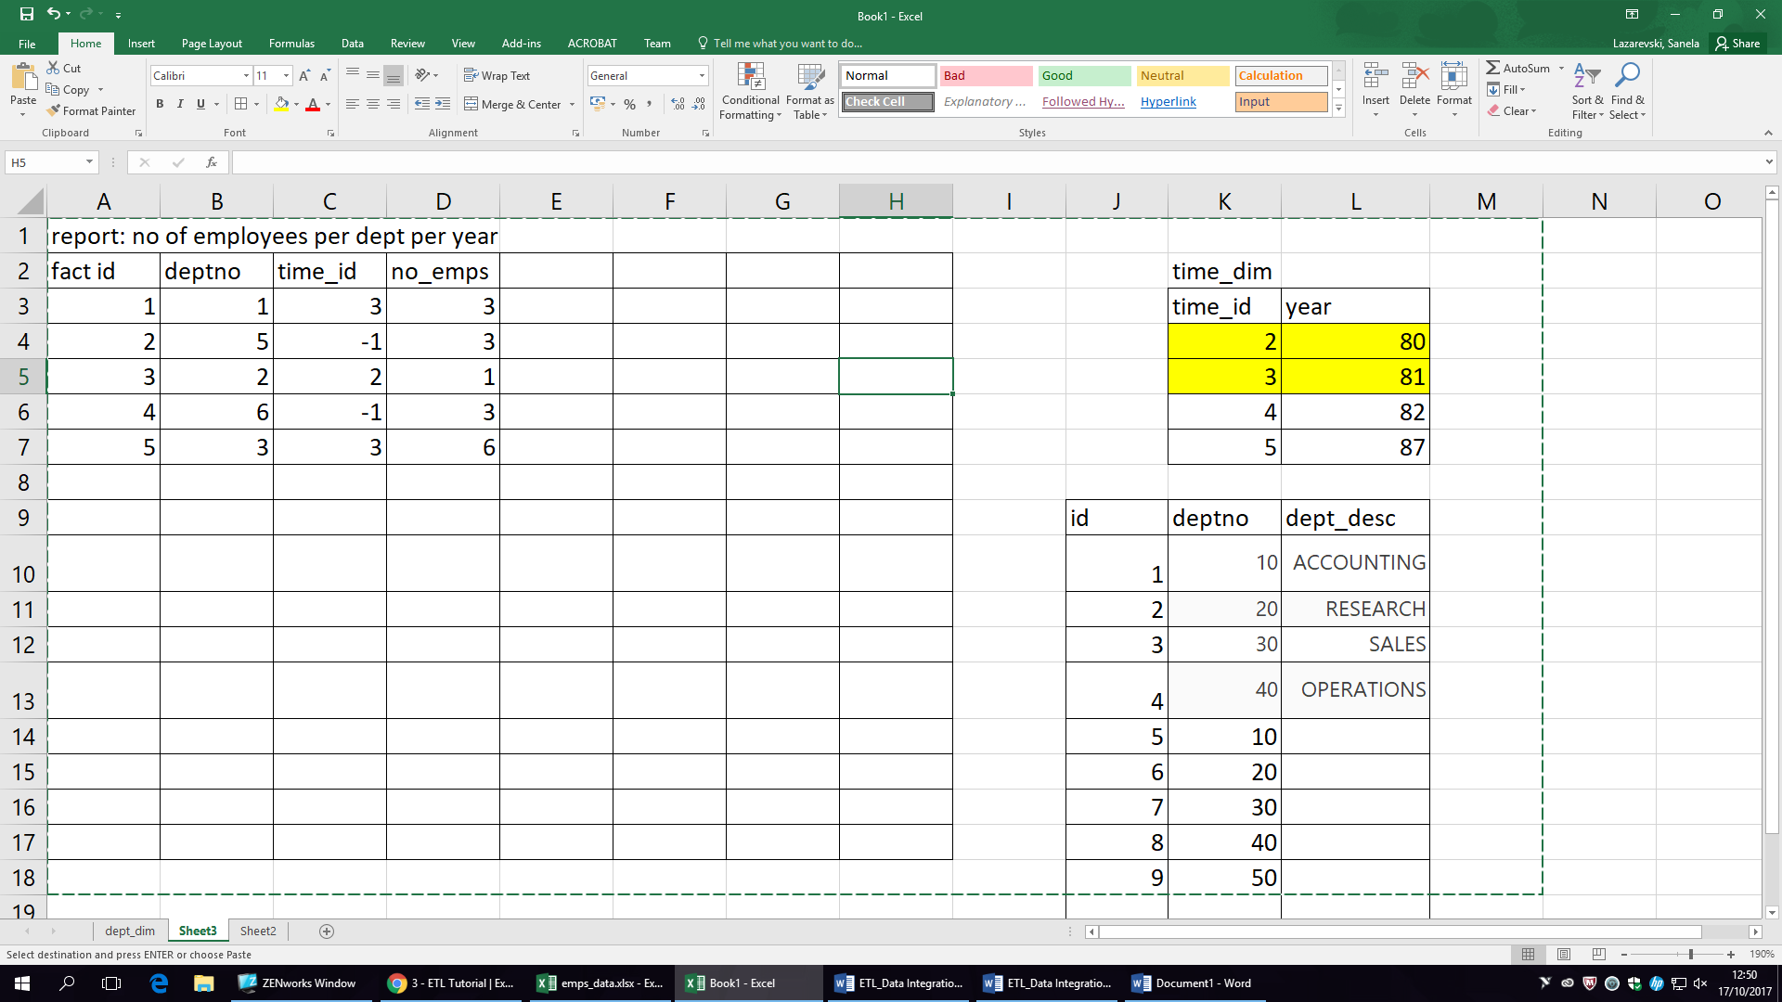

Task 4: Validate the design
Can you find this out/ answer from your data dictionary?
- How long is a time period?
- Where does the deptno on the department dimension come from?
- Have we ‘lost’ the original ids from any of the dimensions? Is this ok?
- Can we support the report no_of_emps per location? Will fact.deptno ever be null? Is this ok?
- Can we find out the no_of_emps per month?
- What happens if the department changes its name? Will we know this?
- How many rows are expected on the fact table?
- How many new rows will be added to the fact table and how often?
- What indexes are on the fact table?

Add to data dictionary – information of where the original data sources are
Mappings –
And transformations, data quality checks

Script to set up Fact and dim tables:
--------------------------------------------------------------
-- Database creation Script
-- Auto-Generated by QSEE-SuperLite (c) 2001-2004 QSEE-Technologies Ltd.
--------------------------------------------------------------
-- Table Creation --
-- Each entity on the model is represented by a table that needs to be created within the Database.
-- Within SQL new tables are created using the CREATE TABLE command.
-- When a table is created its name and its attributes are defined.
-- The values of which are derived from those specified on the model.
-- Certain constraints are sometimes also specified, such as identification of primary keys.
DROP table dept_dim CASCADE CONSTRAINTs;
DROP table time_dim CASCADE CONSTRAINTs;
DROP table fact_emp CASCADE CONSTRAINTs;
-- Create a Database table to represent the "dept_dim" entity.
CREATE TABLE dept_dim(
deptno INTEGER NOT NULL,
dept_desc VARCHAR(10),
Date_effective DATE, -- to support SCD type 3
-- Specify the PRIMARY KEY constraint for table "dept_dim".
-- This indicates which attribute(s) uniquely identify each row of data.
PRIMARY KEY (deptno)
);
-- Create a Database table to represent the "time_dim" entity.
CREATE TABLE time_dim(
time_id INTEGER NOT NULL,
time_period INTEGER,
-- Specify the PRIMARY KEY constraint for table "time_dim".
-- This indicates which attribute(s) uniquely identify each row of data.
PRIMARY KEY (time_id)
);
CREATE TABLE fact_emp(
fact_id INTEGER NOT NULL,
Deptno INTEGER NOT NULL,
time_id INTEGER NOT NULL,
no_employees INTEGER,
PRIMARY KEY (fact_id));
--------------------------------------------------------------
-- Alter Tables to add fk constraints --
-- Now all the tables have been created the ALTER TABLE command is used to define some additional
-- constraints. These typically constrain values of foreign keys to be associated in some way
-- with the primary keys of related tables. Foreign key constraints can actually be specified
-- when each table is created, but doing so can lead to dependency problems within the script
-- i.e. tables may be referenced before they have been created. This method is therefore safer.
-- Alter table to add new constraints required to implement the "relates_to" relationship
-- This constraint ensures that the foreign key of table "FACT_emp"
-- correctly references the primary key of table "dept_dim"
ALTER TABLE FACT_emp ADD CONSTRAINT fk1_FACT_emp_to_dept_dim FOREIGN KEY(deptno) REFERENCES dept_dim(deptno) ;
-- Alter table to add new constraints required to implement the "relates_to" relationship
-- This constraint ensures that the foreign key of table "FACT_emp"
-- correctly references the primary key of table "time_dim"
ALTER TABLE FACT_emp ADD CONSTRAINT fk2_FACT_emp_to_time_dim FOREIGN KEY(time_id) REFERENCES time_dim(time_id) ;
--------------------------------------------------------------
-- End of DDL file auto-generation
--------------------------------------------------------------

